SCHEDULE 14A
Proxy Statement Pursuant to Section 14(a)

of the Securities Exchange Act of 1934

Filed by the Registrant ☐

Filed by a Party other than the Registrant ☑

Check the appropriate box:

- Preliminary Proxy Statement
- Confidential, for Use of the Commission Only (as permitted by Rule 14a-6(e)(2))
- Definitive Proxy Statement
- Definitive Additional Materials
- Soliciting Material Under Rule 14a-12

Avis Budget Group, Inc.

(Name of Registrant as Specified In Its Charter)

SRS Investment Management, LLC
Karthik R. Sarma
Brian Choi
Matthew Espe
Jagdeep Pahwa
Carl Sparks
Sanoke Viswanathan

(Name of Person(s) Filing Proxy Statement, if other than the Registrant)

Payment of Filing Fee (check the appropriate box):

- No fee required.

- Fee computed on table below per Exchange Act Rule 14a-6(i)(4) and 0-11.

  - Title of each class of securities to which transaction applies:

  - Aggregate number of securities to which transaction applies:

Per unit price or other underlying value of transaction computed pursuant to Exchange Act Rule 0-11 (set

  - forth the amount on which the filing fee is calculated and state how it was determined):

  - Proposed maximum aggregate value of transaction:

  - Total fee paid:

- Fee paid previously with preliminary materials.

- Check box if any part of the fee is offset as provided by Exchange Act Rule 0-11(a)(2) and identify the filing for which the offsetting fee was paid previously. Identify the previous filing by registration statement number, or the Form or Schedule and the date of its filing.

  - Amount Previously Paid:

  - Form, Schedule or Registration Statement No.:

  - Filing Party:

  - Date Filed:

After the close of business on February 15, 2018, SRS Investment Management, LLC (“SRS”) issued a public letter to stockholders of Avis Budget Group, Inc. (the “Company”) in the form of a press release (the “SRS Press Release”). A copy of the SRS Press Release is filed herewith as Exhibit 1. A copy of the SRS Press Release, including various soliciting materials can be found on SRS’s website www.driveavisforward.com (the “Website”). Copies of the Materials posted to the Website are filed herewith as Exhibit 2.

In addition, information regarding the Participants (as defined in Exhibit 3) in a stockholder notice of intent to nominate persons for election as directors at the 2018 annual meeting of stockholders of the Company is filed herewith as Exhibit 3.

Exhibit 1

SRS INVESTMENT MANAGEMENT NOMINATES FIVE HIGHLY QUALIFIED

DIRECTORS TO AVIS BOARD

NEW YORK, NY (February 15, 2018) – SRS Investment Management, LLC (“SRS”), which owns a 31% economic interest and has been the largest stockholder of Avis Budget Group, Inc. (the “Company” or “Avis”) (NASDAQ: CAR) for the past seven years, today announced that it has nominated five highly-qualified and motivated individuals for election as directors to the Avis Board at the Company’s upcoming annual meeting.

The nominees include two existing Avis Board members and three new nominees:

Matthew Espe
Carl Sparks
Brian Choi
Jagdeep Pahwa
Sanoke Viswanathan

This press release along with additional information on each of the nominees is available at www.driveavisforward.com.

SRS also issued the following statement:

“SRS’s commitment to the long-term success of the Company is demonstrated not only by the length of our association with Avis but also by the extent of economic ownership that it has maintained during this time. Currently, SRS owns a 31% economic interest in Avis through a combination of 12 million shares in stock (~15%) and economic exposure to an additional 13 million shares (~16%). SRS’s support for the Company has been unwavering despite significant share price volatility. In fact, SRS is the only hedge fund that has remained the largest investor in any Fortune 500 company for the past seven years.

Over the past two years, through its representation on the board, SRS has engaged more closely with the Avis management team and non-SRS representatives of the board (“Legacy Board”). Although this additional involvement has strengthened SRS’s belief in the great long-term value of the business, it also has made clear that the Company cannot achieve its full potential under the stewardship of the current Legacy Board.

In SRS’s view, the Legacy Board suffers from a fundamental problem of entrenchment. Of the 10 board members that are not SRS designees, three are former/current executives of Avis and six of the remaining seven have what ISS describes as compromisingly lengthy tenures of nine or more years. The seventh board member is the chairman of another public company board where Ronald Nelson (the Executive Chairman of Avis) serves as the lead director. This board composition clearly exemplifies lack of independent objectivity.

For nearly a decade, no movement has been made to refresh the Legacy Board despite the substantial change occurring in the mobility industry. The resulting unhealthy dynamic between the Legacy Board and the management team has created a culture of complacency resulting in weak operating performance and a neglect of the board’s fiduciary duties to its stockholders. Specific examples directly attributable to this failing are outlined below:

- The Legacy Board has not held management accountable for its recurring failure to deliver on operating and financial targets.

- The Legacy Board has taken no meaningful action to address the failure to satisfy the commitments it made to stockholders at Avis’s 2016 Investor Day regarding the implementation of a ground-up plan to achieve higher EBITDA margins over a five-year period.

- The Legacy Board has exhibited inaction and a startling lack of urgency throughout the entire search process for a permanent Chief Financial Officer.

- The Legacy Board has displayed, in our view, poor corporate governance and a disregard of its fiduciary duty to maximize value for Avis stockholders on a number of occasions.

These failures can only be resolved by refreshing the board with a new Chairman and independent directors who will hold management accountable. Furthermore, SRS believes the board needs the technology expertise required to navigate the rapidly evolving world of mobility. Several of the key initiatives that the new board should focus on include: (1) agreeing on the top strategic priorities for the Company, (2) developing a medium term plan for accelerating EBITDA growth in the core business, (3) strengthening the management team specifically by hiring a world class CFO, (4) creating a performance and data-driven culture with a focus on meritocracy over tenure, and (5) aligning management compensation with performance targets and stockholder returns.

SRS remains a firm believer in Avis’s long-term potential for value creation. We believe the stock is worth significantly more than what is reflected in its current share price. Avis has a truly global brand with 70 years of history and an excellent core business that generates significant cash flow. Avis is a uniquely scarce asset that has the potential to play a critical role in the future mobility ecosystem. However, in our opinion, what is lacking is the guidance and leadership from an independent board that is equipped to help the Company leverage its strengths to further improve its operating and financial metrics while making the necessary investments to take advantage of rapid technological changes.

To address this critical shortcoming, SRS has assembled a slate of five directors comprising two existing directors and three new directors. The two existing directors have served admirably as board members in the face of what we believe is structural entrenchment and group complacency. The three new directors (two independent directors and one SRS representative) are all highly qualified and motivated nominees who will guide Avis to maximize value for Avis stockholders. We look forward to the support from Avis stockholders to drive Avis forward.”

About the SRS Director Nominees

Matthew Espe

Matt has more than 30 years of experience in sales, marketing and management of global businesses. He successfully led multi-billion dollar manufacturing, infrastructure and services companies with up to 34,000 employees globally.

In his most recent executive role, Matt was recruited by Sterling Partners to serve as Chief Executive Officer of Radial, Inc., a leading international omni-channel commerce technology and operations provider for retailers and brands. After an eight-week enterprise assessment, he recommended and led the successful sale of Radial to Belgian Post.

Prior to Radial, Matt served as CEO of Armstrong Industries, a $2.9B global building products company, retiring in March, 2016. During his tenure he improved profit & loss, drove leadership, operational and strategic improvements increasing ROIC and equity value by 75%. Prior to Armstrong he was Chairman & CEO of IKON Office Solutions a $4.9B document management services company. He transformed the company’s business model and nearly doubled shareholder value following a $1.6B merger with Ricoh Japan. Prior to IKON, Matt enjoyed a 23-year career with General Electric Company advancing through roles across its various businesses globally, including tenures as head of businesses in Europe and Asia, and ultimately served as President and Chief Executive Officer of GE Lighting.

Matt is currently an operating partner with Advent International. He is a member of the board of directors at WESCO International and Realogy Holdings. He is a member of the National Board of Summer Search, and a member of the Advisory Boards of Drexel University’s LeBow College of Business and of the University of Idaho and Member of the Board of Trustees of ECS Philadelphia.

He was formerly a member of the board of directors of Husky Injection Molding Systems Ltd., NCI Building Systems, Inc., Veritiv Corporation, Armstrong World Industries, Inc., IKON Office Solutions, Inc., Graphic Packaging Holding Company, Unisys Corporation, Con-way Inc. and Ricoh Americas Corporation.

Carl Sparks

Carl is a seasoned executive with proven large scale operating leadership in complex digital environments. He has successfully led multiple growth and transformational efforts at large scale and entrepreneurial companies and provides expertise in digital marketing, brand management, and innovation.

In his most recent executive role, Carl served as Chief Executive Officer of Academic Partnerships, an Insight Ventures-backed provider of online higher education technologies to public and private not-for-profit universities. Prior to Academic Partnerships, Carl was recruited by TPG and Silver Lake to lead a turnaround of Travelocity Global, formerly a division of Sabre Inc. During his tenure as Chief Executive Officer, he successfully recast an unprofitable portfolio into a more streamlined and profitable business while realizing value through divestment of non-core businesses to regional competitors. He rejuvenated topline growth of its remaining core brands and led a sales process culminating in an acquisition by Expedia.

Prior to Travelocity, Carl served as President of Gilt.com, an invitation-only online retailer of luxury products and experiences. He was responsible for a P&L comprising over $400M in annual revenue across 5 business lines, and led the formation of business strategies and organizational growth to drive Gilt to be a leading lifestyle brand in e-commerce, with over 3 million members and 1,000+ premium brand partners. He previously spent five years at Expedia across a variety of leadership roles, including tenure as the General Manager of Hotels.com, the second largest business for Expedia, where he was responsible for a P&L comprising $2B in annual bookings and drove double-digit revenue growth and share gains in an extremely competitive market, outpacing its largest four competitors.

Carl is currently a member of the board of directors at Dunkin’ Brands Group [NASDAQ: DNKN] and ActionIQ, a market-leading Customer Data Platform for enterprise marketers, analysts, and technologists backed by Sequoia Capital and Andreessen Horowitz. He also serves as an Advisor to SecurityScorecard, Inc., developer of a cyber security rating and continuous monitoring platform.

He recently announced the end of his seven-year tenure on the board of directors at Vonage Holdings, where he chaired the search committee to hire the current Vonage Chief Executive Officer. Carl graduated summa cum laude from Princeton University and received his MBA with highest distinction from Harvard University.

Brian Choi

Brian Choi has served on the Board of Avis Budget Group, Inc. since 2016. Additionally, Brian serves as a Partner at SRS Investment Management, LLC, where he has served in various roles since 2008.

Prior to SRS, Brian worked at Metalmark Capital (formerly Morgan Stanley Capital Partners), a private equity firm focusing on the natural resources, industrials and healthcare sectors. Prior to Metalmark Capital, Brian began his career working in the Investment Banking Division of Lehman Brothers in the Leverage Finance Group.

Brian holds a Bachelor of Arts, Economics from Harvard University.

Brian’s qualifications to serve as director include his financial and industry expertise, his diverse background working in the travel, leisure and technology sectors, as well as the continuity he can bring to Avis as a current director of the Company.

Jagdeep Pahwa

Jagdeep Pahwa has served as the President of SRS Investment Management, LLC since 2017 after having been affiliated with SRS since 2006.

Jagdeep has over 18 years of experience across finance, consulting and investing, beginning his career at Lehman Brothers in their Mergers & Acquisitions group in New York. Subsequently, Jagdeep worked at McKinsey & Company in the US and India, where he led client engagements in the telecom, technology and real estate sectors. Jagdeep has been leading SRS’s private equity business since 2006.

Jagdeep received a Bachelor of Technology from the Indian Institute of Technology, Delhi, an MS from Princeton University and an MBA from Harvard Business School.

Jagdeep’s qualifications to serve as a director include his understanding of the technology sector, his years of experience in the financial industry and his deep knowledge of growing and developing businesses.

Sanoke Viswanathan

Sanoke Viswanathan has served on the Board of Avis Budget Group, Inc. since 2016. Since 2014, Sanoke has served as the Chief Administrative Officer of JPMorgan Chase & Co.’s Corporate & Investment Bank (CIB), overseeing Technology, Operations and Controls.

From 2012 to 2013, Sanoke was head of Strategy, Marketing and New Business Development for CIB and head of Corporate Strategy for JPMorgan Chase. Prior to joining JPMorgan Chase, Sanoke was a partner at McKinsey & Co. and co-head of its global corporate and investment banking practice, serving financial institutions in Asia, Europe and North America on strategy, organization and risk management topics. Sanoke has been on the Board of Sadler’s Wells Theatre in London since 2014.

Sanoke holds a Bachelor of Technology from the Indian Institute of Technology, Madras and an M.B.A. from the Indian Institute of Management Ahmedabad.

Sanoke’s qualifications to serve as a director include his key insight into Avis’s existing business operations, deep understanding of the travel industry, his strong leadership capabilities from serving as a chief administrative officer and his significant experience working with financial institutions.

Legend

SRS Investment Management, LLC (“SRS”), Karthik R. Sarma (“Mr. Sarma,” together with SRS, the “SRS Parties”), Brian Choi, Matthew Espe, Jagdeep Pahwa, Carl Sparks and Sanoke Viswanathan (collectively, the “Nominees,” together with the SRS Parties, the “Participants”) intend to file with the Securities and Exchange Commission (the “SEC”) a definitive proxy statement and accompanying form of proxy to be used in connection with the solicitation of proxies from the stockholders of Avis Budget Group, Inc. (the “Company”). All stockholders of the Company are advised to read the definitive proxy statement and other documents related to the solicitation of proxies by the Participants when they become available, as they will contain important information, including additional information related to the Participants. The definitive proxy statement and an accompanying proxy card will be furnished to some or all of the Company’s stockholders and will be, along with other relevant documents, available at no charge on the SEC website at http://www.sec.gov/.

Information about the Participants and a description of its direct or indirect interests by security holdings is contained in the Schedule 14A filed by SRS with the SEC on February 15, 2018. This document is available free of charge from the sources indicated above.

Investors Contact:

Okapi Partners LLC
Bruce H. Goldfarb/Pat McHugh/Dan Niebler
Telephone: +1 212-297-0720
Email: info@okapipartners.com

Media Contact:

ASC Advisors LLC
Taylor Ingraham/Steve Bruce

(203) 992-1230

Exhibit 2

Website Soliciting Materials
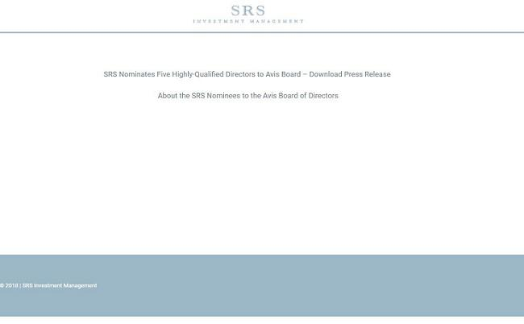

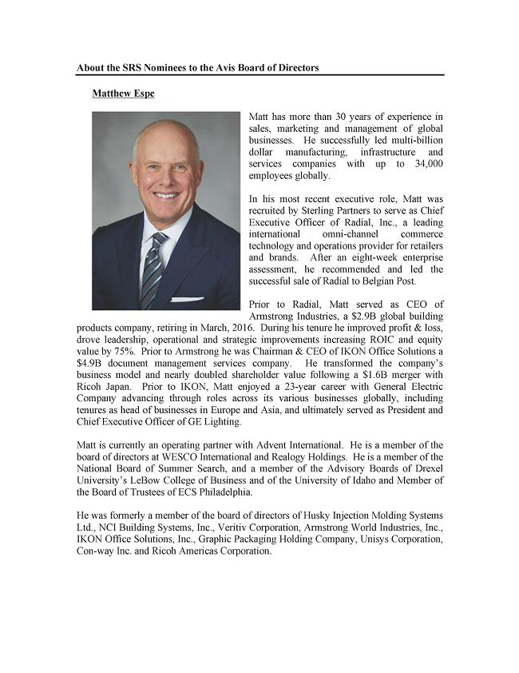

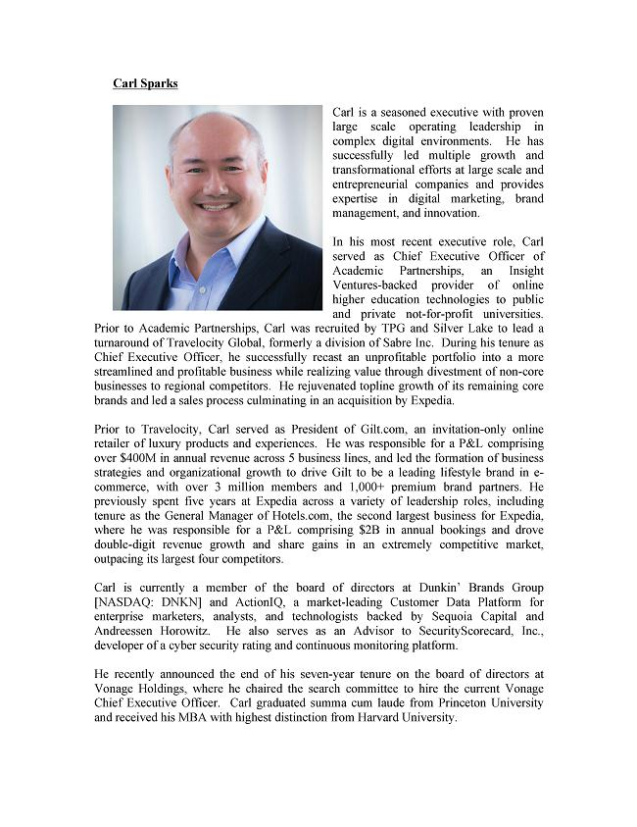

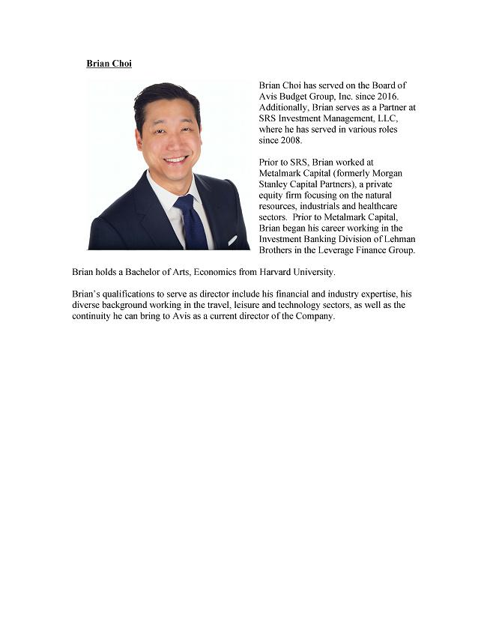

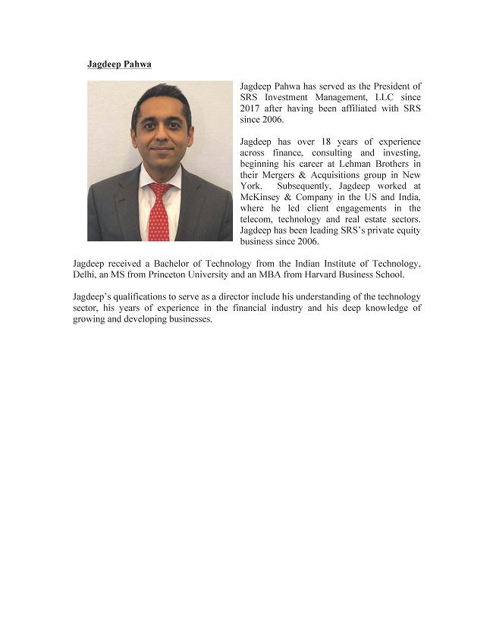

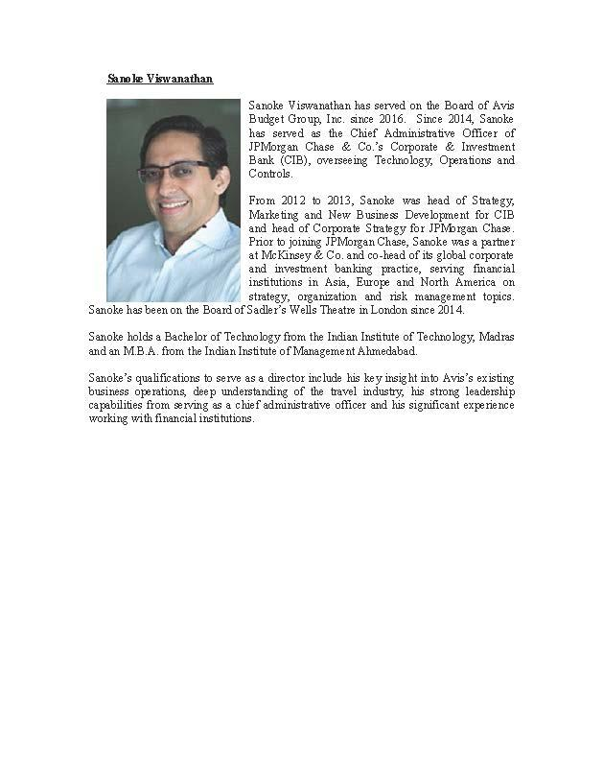

Exhibit 3

SRS Investment Management, LLC (“SRS”), Karthik R. Sarma (“Mr. Sarma,” together with SRS, the “SRS Parties”) and Brian Choi, Matthew Espe, Jagdeep Pahwa, Carl Sparks and Sanoke Viswanathan (collectively, the “Nominees,” together with the SRS Parties, the “Participants”) intend to file with the Securities and Exchange Commission (the “SEC”) a definitive proxy statement and accompanying form of proxy to be used in connection with the solicitation of proxies from the stockholders of Avis Budget Group, Inc. (the “Company”). All stockholders of the Company are advised to read the definitive proxy statement and other documents related to the solicitation of proxies by the Participants when they become available, as they will contain important information, including additional information related to the Participants. The definitive proxy statement and an accompanying proxy card will be furnished to some or all of the Company’s stockholders and will be, along with other relevant documents, available at no charge on the SEC website at http://www.sec.gov/.

INFORMATION ABOUT THE PARTICIPANTS

The Participants in this solicitation of proxies from stockholders of Avis Budget Group, Inc. (the “Company”) in connection with the Company’s 2018 annual meeting of stockholders are: (i) SRS Investment Management, LLC (“SRS”), (ii) Karthik R. Sarma (“Mr. Sarma,” together with SRS, the “SRS Parties”), (iii) Brian Choi, (iv) Matthew Espe, (v) Jagdeep Pahwa, (vi) Carl Sparks and (vii) Sanoke Viswanathan (“Mr. Viswanathan”).

Collectively, the Participants may be deemed to “beneficially own” (within the meaning of Rule 13d-3 under the Exchange Act) an aggregate of 12,005,554 shares of Common Stock, representing approximately 14.7% of the Company’s outstanding Common Stock. Share ownership is reported as of the date hereof. The percentages contained herein are based upon a total of 81,421,558 shares of Common Stock outstanding as of October 31, 2017, as reported in the Company’s Form 10-Q filed with the SEC on November 7, 2017. Pursuant to certain cash-settled equity swaps between the Funds and broker-dealer counterparties, the SRS Parties have economic exposure to an additional 12,996,000 notional shares of Common Stock, constituting approximately 16% of the outstanding shares of Common Stock, as more fully described in Item 6 of this Schedule 13D. In addition, pursuant to certain options, the SRS Parties have economic exposure to an additional 4,000 notional shares of Common Stock, constituting less than 0.1% of the outstanding shares of Common Stock.

Of the 12,005,554 shares of Common Stock beneficially owned in the aggregate by the Participants: (a) 12,000,000 shares of Common Stock may be deemed to be beneficially owned by SRS by virtue of it being the investment manager of certain affiliated funds and managed accounts directly holding such shares of Common Stock, (b) Mr. Sarma may be deemed to beneficially own 12,000,000 shares of Common Stock by virtue of his direct and indirect control of SRS, and (c) Mr. Viswanathan beneficially owns 5,554 shares of Common Stock, which he received pursuant to the terms of the Company’s Non-Employee Directors Deferred Compensation Plan.

Each of the SRS Parties expressly disclaim beneficial ownership of the shares of Common Stock held by Mr. Viswanathan. Mr. Viswanathan expressly disclaims beneficial ownership of the shares of Common Stock held by each of the SRS Parties.

